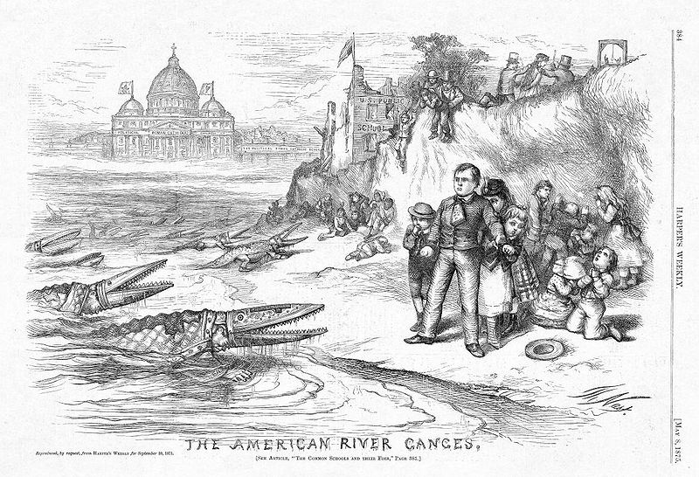
Nast, Thomas. “The American River Ganges.” 1871. The Ohio State University Thomas Nast Database. Web. 4 September 2014.

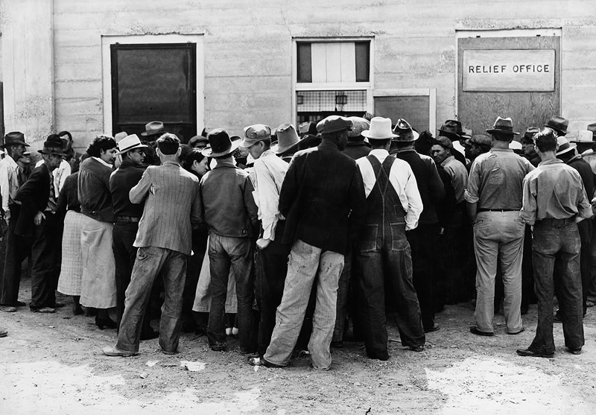
Lange, Dorothea. “A group of migrants waiting for relief checks outside of an office, California.” 1937. The Dust Bowl Photo Gallery. PBS. 2012. Web. 4 September 2014.

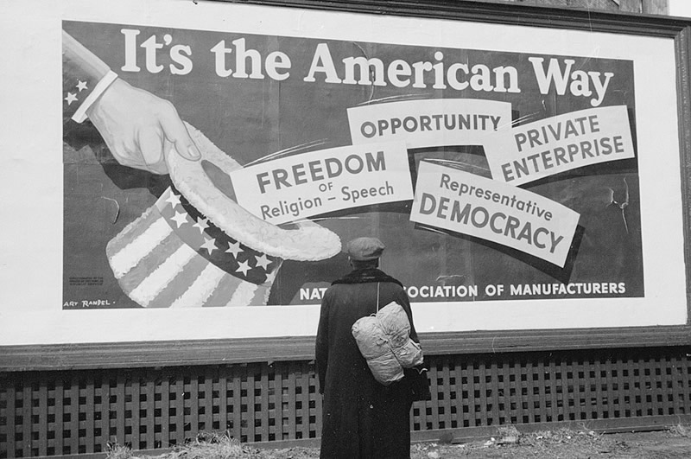
Vachon, John. “American man looking up at billboard, Iowa.” 1940. The Dust Bowl Photo Gallery. PBS. 2012. Web. 4 September 2014.

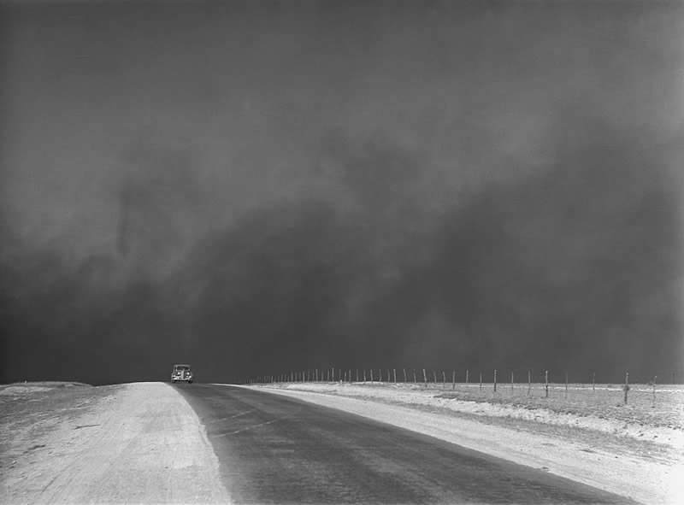
Rothstein, Arthur. “A car is chased by a ‘black blizzard’ in the Texas Panhandle.” 1936. The Dust Bowl Photo Gallery. PBS. 2012. Web. 4 September 2014.

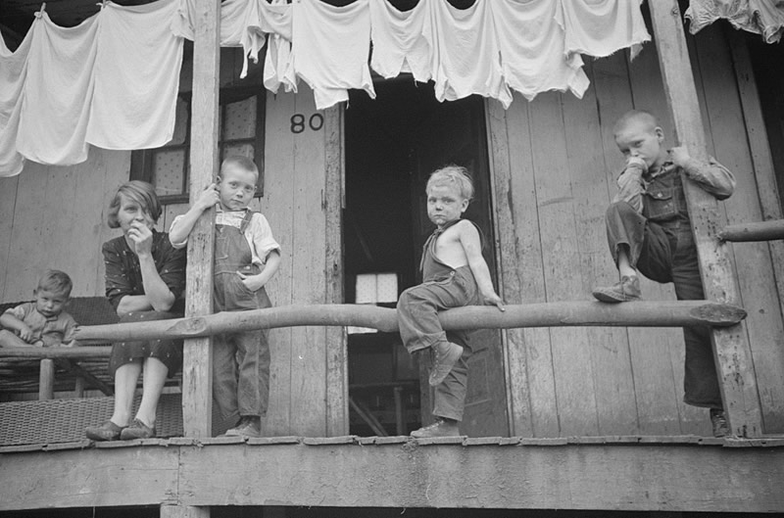
Post Walcott, Marion. “Children on porch, leaning on railing. Pursglove, West Virginia.” 1938. The Dust Bowl Photo Gallery. PBS. 2012. Web. 4 September 2014.

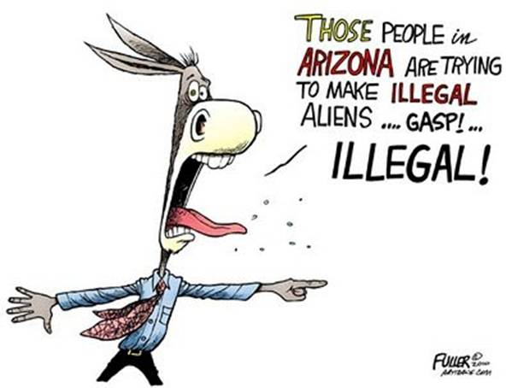
Fuller, Jake. “Arizona immigration law editorial cartoon.” 30 April 2010. The American Association of Editorial Cartoonists. Web. 4 September 2014.

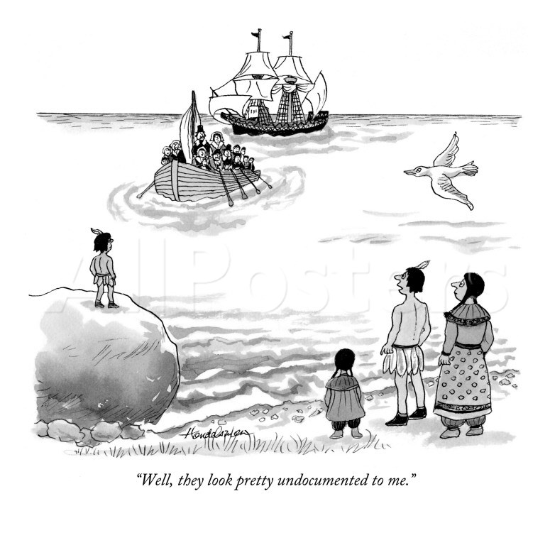
Handlesman, J.B. “Well, they look pretty undocumented to me.” Digital image. The Conde Nast Collection. Art.com. Web. 4 September 2014.

Originally published in The New Yorker 10 April 2006.

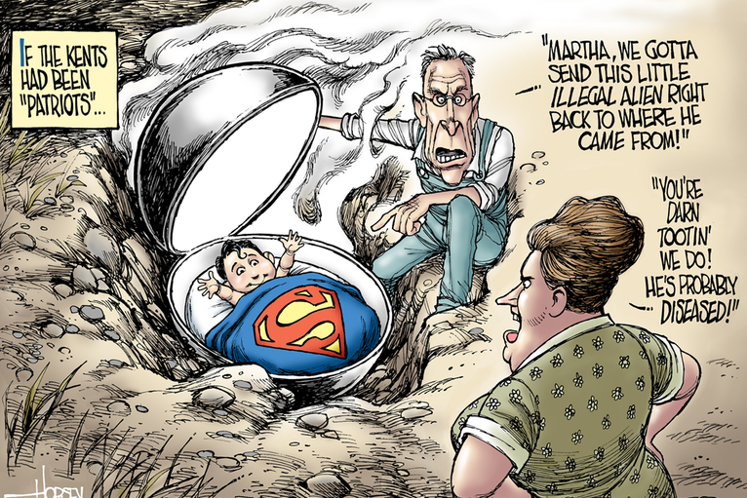
Horsey, David. “If the Kents had been ‘Patriots.’” The LA Times. 25 July 2014. Immigration Cartoons. U.S. News & World Reports. Web. 4 September 2014.

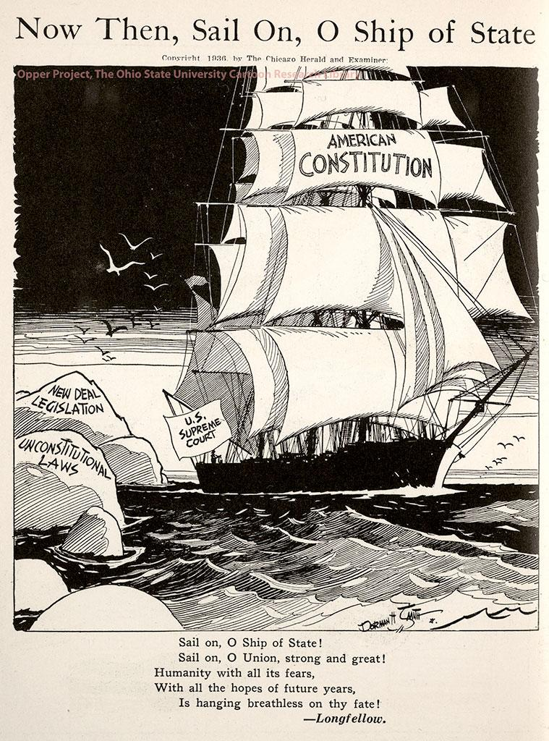
Brown, Dorman. “Now Then, Sail on, O Ship of State.” 1936. Editorial Cartoon. The Opper Project: Using Editorial Cartoons to Teach History. The Ohio State University Cartoon Research Library. Web. 4 September 2014.

Text published with this image:

Franklin Delano Roosevelt was elected in 1932 by a large majority of the voters who were unhappy with Herbert Hoover’s handling of the crisis of the Great Depression. Hoover’s adherence to traditional economic doctrine, and his belief that the economy could eventually correct itself had become unpopular with the American people.. Roosevelt showed a willingness to not only experiment with economic solutions, but also to try to fundamentally change American government to better protect the people. The New Deal focused on the “Three Rs”: Relief, Recovery and Reform. At the same time that many Americans approved of relief efforts, there were also many who felt that the New Deal was unconstitutional and represented an unwarranted expansion of Federal power. The Supreme Court declared much of the New Deal unconstitutional based on the idea that the market should not be manipulated by government regulation.

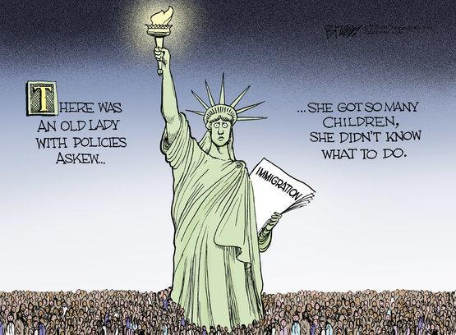
Breen, Steve. “There was an old lady.” 2014. Immigration Cartoons. U.S. News & World Reports. Web. 4 September 2014.

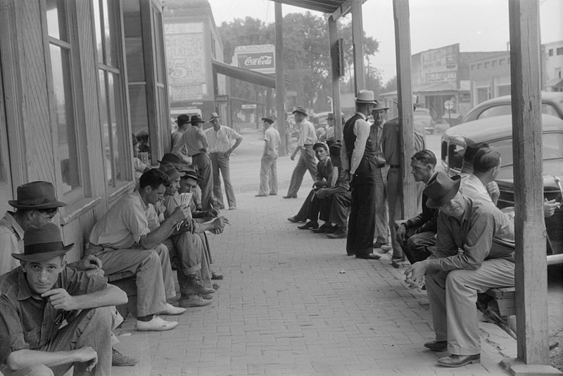
Delano, Jack. Unemployed men outside of stores in town. Childersburg, Alabama. The Dust Bowl Photo Gallery. PBS. 2012. Web. 4 September 2014.

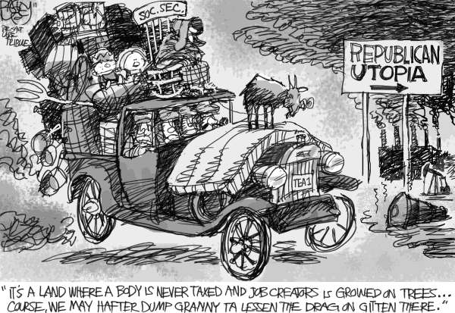
Bagley, Pat. “The Gripes of Wrath.” Salt Lake Tribune. 14 July 2011. Daryl Cagle’s PoliticalCartoons.com Store. PoliticalCartoons.com. Web. 4 September 2014.

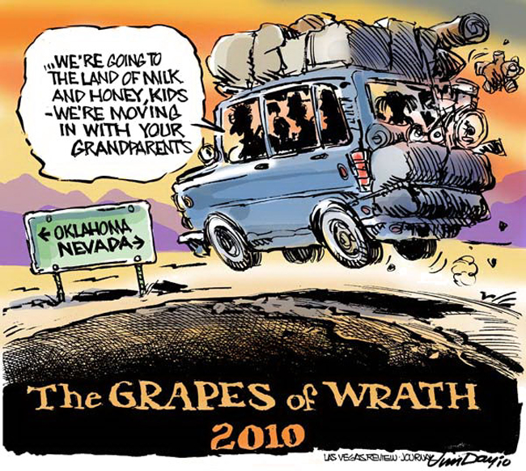
Day, Jim. “The Grapes of Wrath 2010.” The Las Vegas Review-Journal. Daryl Cagle’s PoliticalCartoons.com Store. PoliticalCartoons.com. Web. 4 September 2014.

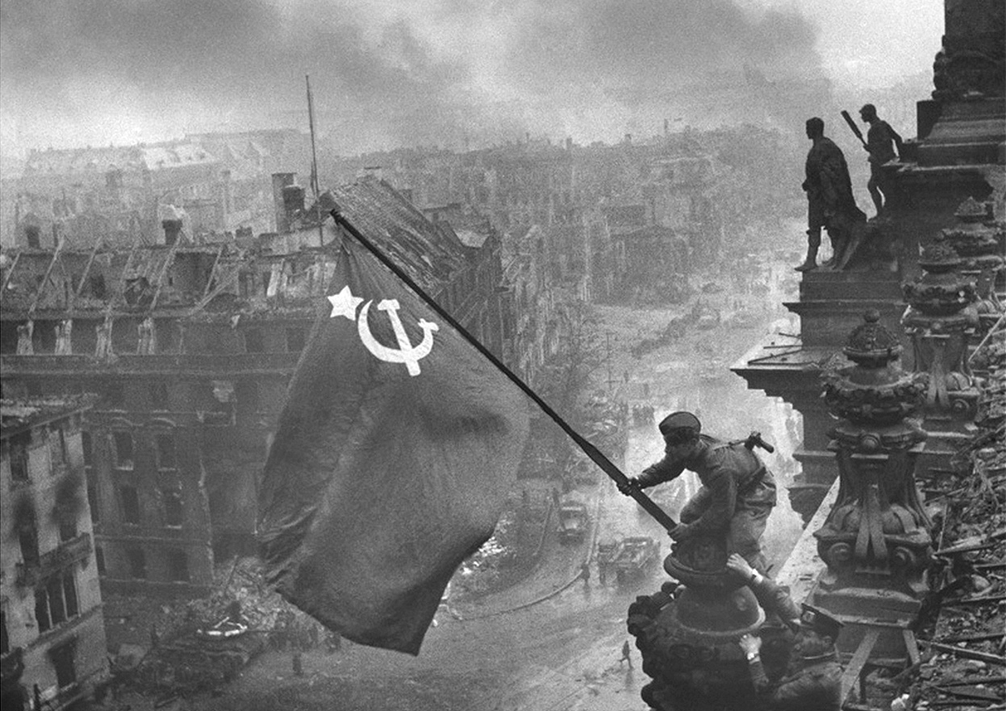
Khaldei, Yavgeny. “Raising a Flag over the Reichstag.” 1945. World War II In Photographs. The Atlantic. 9 October 2011. Web. 8 September 2014.

Caption from The Atlantic: "Raising a flag over the Reichstag" the famous photograph by Yevgeny Khaldei, taken on May 2, 1945. The photo shows Soviet soldiers raising the flag of the Soviet Union on top of the German Reichstag building following the Battle of Berlin. The moment was actually a re-enactment of an earlier flag-raising, and the photo was embroiled in controversy over the identities of the soldiers, the photographer, and some significant photo editing. More about this image from Wikipedia. (Yevgeny Khaldei/LOC)

